Technical Project Team

Azure Client VPN Configuration

SOP

PREPARED BY
Kelvin Aruin – Senior Technical Project Engineer

- Download and install the Azure VPN client from the Microsoft Store
  - Direct Link: https://apps.microsoft.com/store/detail/azure-vpn-client/9NP355QT2SQB?hl=en-np&gl=NP
- In the Azure Portal, under the User VPN configurations tab, select the Client VPN deployment and click Download virtual WAN user VPN profile
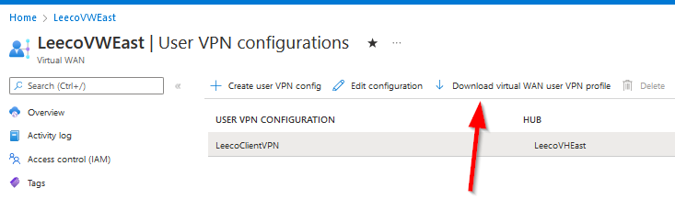
- Select the only Authentication type option EAPTLS
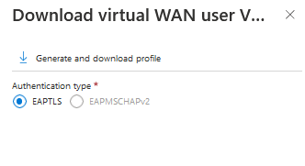
- Click Generate and Download profile
- The downloaded archive needs to be extracted to a folder

- Open the Azure VPN Client and click the + button, then select Import
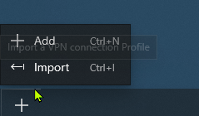
- Browse to the directory that contains the extracted archive folder, and browse into the AzureVPN folder inside
- Select the XML file called azurevpnconfig.xml then press Open
- The XML file will auto-populate all of the necessary connection information fields, and attach the certificate, therefore there is no need to change any of the fields except the Connection Name, then press Save

- The newly created connection will now appear in the left side bar, under VPN Connections
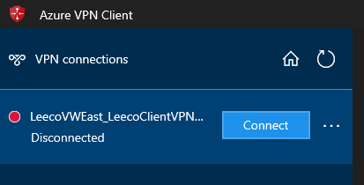
- Select the VPN Connection then press Connect
- When connecting for the first time you will be prompted to authenticate, select 'Use a different account' and then 'Work or school account' and press continue
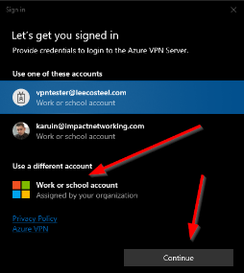
- Enter your O365 username/email address on the next screen
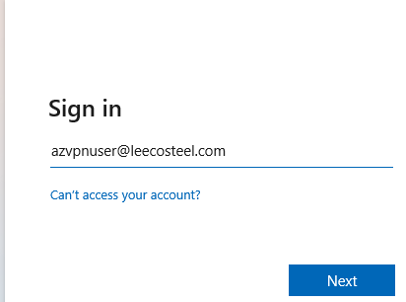
- Press Next
- Enter the account password
- Press Sign in
- Press OK or No, sign into this app only on the following screen
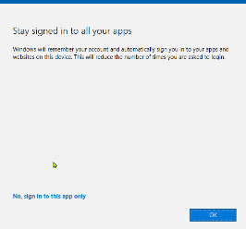
- The VPN client will then try to connect
- When connected you will see a 'Connected' status under the connection name on the left side bar in the Azure VPN Client
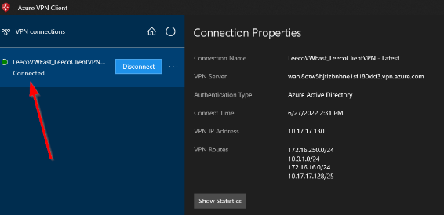
- You are now connected to the Azure VPN
- When finished, press the Disconnect button in the Azure VPN Client to disconnect

